Analysis of Least Significant Digit (LSD) Radix Sort
Radix sort has two main approaches, the Least Significant Digit (LSD) approach and the Most Significant Digit (MSD) approach. This analysis deals with the LSD method, and all references to the radix sort will be to the LSD method.

How it works
Initial 1st loop 2nd loop 3rd loop
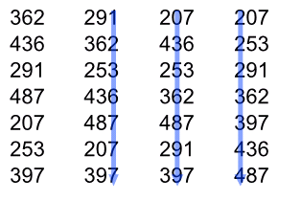
Starting from the position of the least significant digit, the radix sort will analyze all the digits of the integers one by one. During the analysis of each digit, the sort places integers in order from least to greatest as determined by the current digit.
This is done by first organizing integers into “buckets”, which collects all integers having a certain value for a certain digit. Since integers can only have digits ranging from -9 to 9, there will be 20 possible values of each digit, and 20 buckets to collect the integers. After this collection, a new array will be created by emptying the buckets in order from least to greatest according to the value that they represent. For example, integers of bucket -9 will first be empties, followed by -8, and so on. The result of this is an array of integers that have been sorted by a certain digit, from least to greatest. This signifies the end of the sort for one digit.
When the sort finishes analyzing every digit of the integers, the result will be a completely sorted array of integers.

Performance
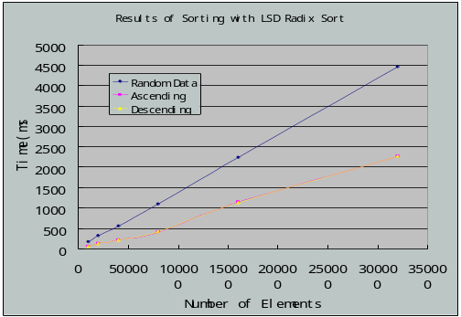
The LSD radix sort is one of the faster sorts available, taking only 13 seconds to sort through 1 million elements. Theoretically, LSD radix sort should have a linear relationship between time and the number of elements, since the sort has to run a set number of times (same number of digits), making the number of elements the only variable. This linear relationship should be the same with random, ascending, and descending data, since the radix sort needs to process every digit and does not check if an array is already sorted.
However, experimental results show that while the graph for an array containing random integers is linear, the graph for ascending and descending data has jumps, and both take less time to sort than a random array. These abnormities can be explained by a flaw in the constructor for the integer array test class, which causes integers in the ascending and descending data to have fewer digits than that of random data. This means that the sort will run faster for ascending and descending data, since there are fewer digits to analyze. This flaw causes the length (number or digits) of the integers to increase as the size of the ascending or descending array increases. This means that the sort not only has to handle twice the amount of data, but it also needs to execute extra loops to account for the extra digits.
Testing shows that if the ascending and descending integer arrays contain integers of the same length as those produced by random integers, the result will be a uniform linear graph.

BIG O
The LSD radix sort has a Big O Notation of O(n), which is supported by the graph of the testing results and representative of a linear relationship between the number of elements and time. This is due to the fact that the LSD radix sort will always loop a set amount of times to analyze the digits, and the only variable changing is the number of elements (assuming increasing the size of array does not change the maximum number of digits). However, it is also important to note that the performance of LSD radix sort is also hugely dependant on the maximum number of digits.

